PICO Central America Annual Report
COFOA: Comunidades de fe Organizadas para Acción
Organized Faith Communities in Action
January 2012

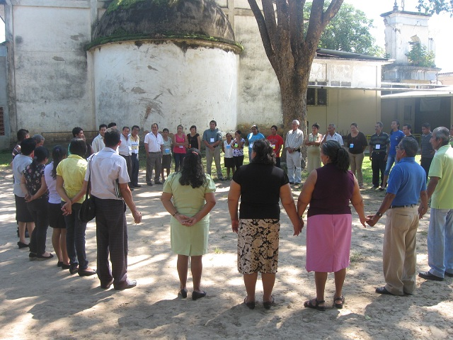
COFOA leaders participate in regional retreat

COFOA (Comunidades de fe Organizadas para Accion) is the first congregation-based community organizing project in Central America and the first international project developed through sponsorship of the US-based PICO Network. COFOA builds grassroots leaders among low-income Central American residents through leadership development that encourages people to identify their dreams and translate their faith into collective action in their congregations and communities.

In 2012, COFOA leaders in El Salvador and Guatemala continued to grow in their ability to bring important change that improves their communities. Hundreds of low-income people participated in ongoing leadership trainings, and together they are sustaining a strong, respected, locally independent organization in El Salvador, and they have expanded to two congregations in Guatemala in response to an invitation by Catholic Bishop Pellecer.
Because of COFOA’s geographic growth and numbers of leaders, late in 2012 seventy-two leaders from El Salvador and Guatemala participated in a three day retreat in San Salvador. The theme of the training was “Power is in the Relationship”, offering COFOA leaders an opportunity to reflect on their public ministry, consider how to build intentional public relationships, and learn a set of practical tools and principles that guide their faith-based organizing. The leaders had a unique opportunity to meet and talk with each other, and they represented a remarkable cross-section of Central Americans who share a desire to empower people to improve their communities.
COFOA El Salvador is working with the following member congregations: Santiago Apostol parish in Santiago Nonualco; Santa Catalina de Alejandria parish in Cuyultitan; San Pedro Apostol parish in San Pedro Nonualco; San Juan Evangelista parish in San Juan Tepezontes; San Luis Rey de Francia in San Luis Talpa; Santa Cruz in Paraiso de Osorio; Jesús del Rescate in Barahona; Nuestra Señora del Perpetuo Socorro, in Rio Blanco; La Resurrección, Astoria (all in the Laz Paz district); San Nicolas Obispo in San Nicolas Lempa, San Vicente; Anglican Episcopal Church Christ the King Mission, El Calix in Baja Lempa, Usulatan.

Expansion efforts are underway to add additional congregations in other departments and to bring in more Catholic dioceses. Recent meetings with Bishop Medardo Gomez of the Lutheran Church and Bishop Martin Barahona of the Anglican Church were fruitful and it is hoped that some of their congregations will join in 2013, as well as a number of evangelical congregations.

COFOA Guatemala is working with two member parishes: San Antonio de Padua in San Antonio Aguas Calientes, Sacatepequez and San Dionisio Aeropagita, in the City of Pastores.
Two additional congregations are actively exploring membership.

At a recent convening of bishops from across Central America, a commitment was made to identify a church in Honduras where we will begin working in 2013.

Highlights of 2012 work

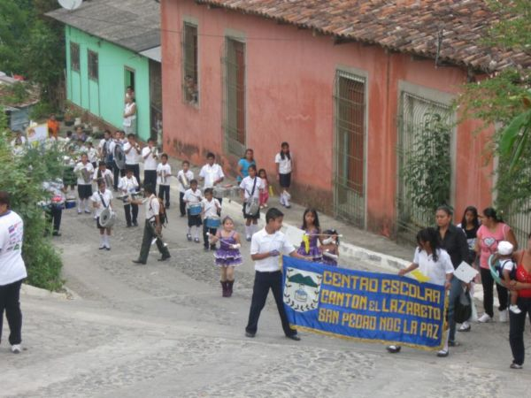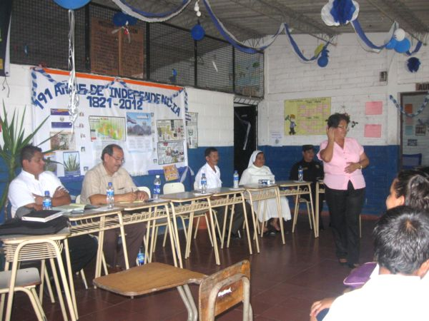
Youth lead peace march in San Pedro Nonualco COFOA leaders hold gang prevention workshop

Youth and leaders from San Pedro Nonualco, El Salvador, held a large peace march with over 600 people, and formed a broad coalition to promote cultural, educational and democratic events that reduce violence and improve the quality of life in their community. They obtained agreements from public officials to create a Strategy and Dialog table to reduce violence, bringing community members together with local authorities and institutions to lead this effort. They were successful in getting commitments by public officials and government agencies to improve coordination that increases safety efforts, and promote community and educational activities for families.

COFOA San Pedro Nonualco leaders are holding a series of workshops focused on violence, including harassment, domestic violence, gang involvement, family communication, migration and violence aimed at women, attended by around 1,300 San Pedro citizens. These workshops are part of the safety campaign launched by the Canton Center Community School in rural Canton La Comunidad, led by the Strategy and Dialog table. A September workshop was attended by 150 parents and students regarding gangs and youth gang involvement. Parents asked that they have assistance from mental health specialists to improve their ability to communicate effectively with their children, especially teens, around these issues.

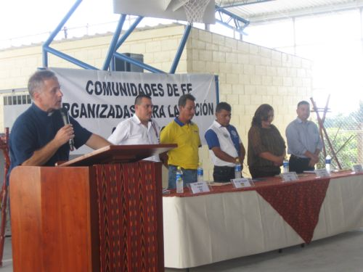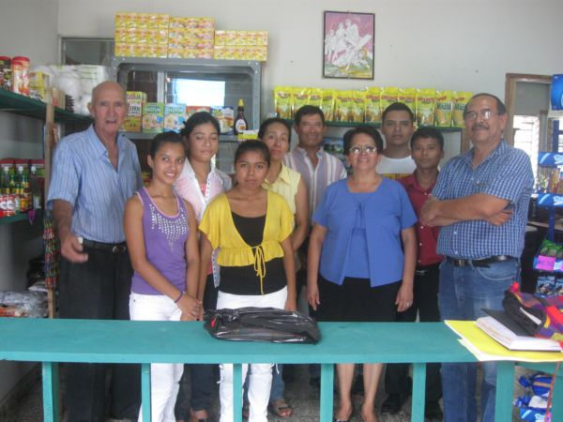
Father Onestini opens a Candidates Forum COFOA leaders and staff celebrate their second store

This June, leaders from San Pedro Nonualco opened their second store through an association they formed called the Foundation for Community Development (FUDECO), with a goal to attract and serve larger numbers of the Sanpedrana community sector. They are holding a listening campaign across the region to introduce the store and their broader goal of reducing poverty through economic development.

The plan for the new store is based on lessons learned after opening the first store in 2011. It is managed by the Pastoral Ministry of the Church of St. Peter the Apostle and members of COFOA. It will distribute 50% of any profits towards community development, such as establishing a childcare center, scholarships for local students, participation with the local government in infrastructure projects (paving streets and providing electricity, drinking water, etc.).

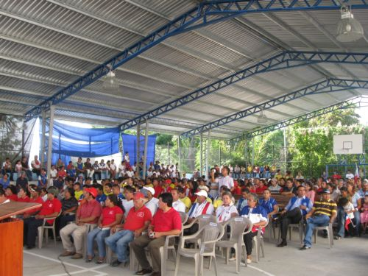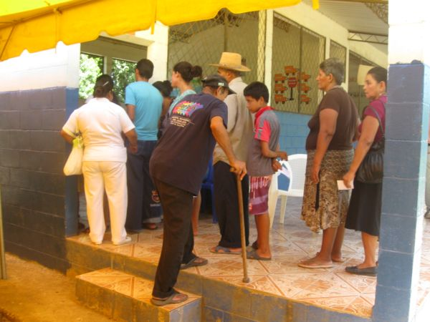
COFOA brings out residents to a Candidates Forum El Calix residents receive medicine
COFOA leaders in four congregations organized non-partisan Candidates Forums attended by over 1000 people. COFOA leaders saw a priority to encourage people in their congregations and towns to vote in the March elections. Four COFOA congregations decided to hold mayoral candidate's forums. Nearly 600 people attended the first of these events, held at San Luis Talpa, our newest member congregation. In San Juan Tepezontes, an even smaller town, 550 showed up for their first forum of this kind. San Luis Talpa leaders prepared for the forum by holding one-to-one conversations and house meetings, and administering a survey during mass, to identify the top concerns of the community. They presented their top issues to all candidates and got their commitment to work with COFOA. Issues that emerged included the need for road repairs, electricity generation, and improved access to clean water.
In September, COFOA Cuyultitan leaders invited the mayor and city council members to an accountability community reunion with 100 church leaders, to give a report about the three issues presented to the mayor in the Candidates Forum, and he reported back about progress regarding safety, garbage management, and alcohol control.
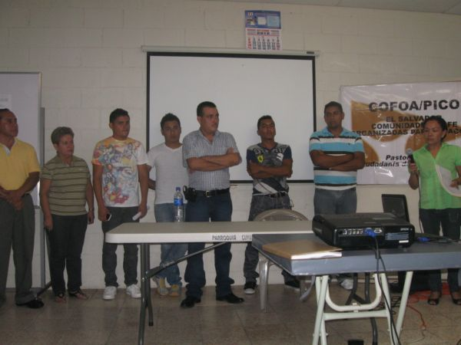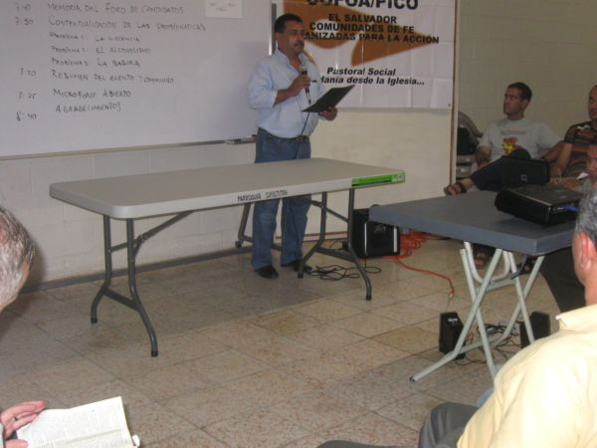
Cuyultitan mayor and city council at accountability reunion Teacher Eduardo Ramirez, COFOA leader

Health care remains a top issue. In August 2012, COFOA leaders from El Calix in Bajo Lempa, Jiquilisco municipality, Usulutan, held a health fair that provided medical services for 200 people from the communities surrounding Calix. The event was organized by COFOA member congregation the Anglican Episcopal Church Christ the King Mission.

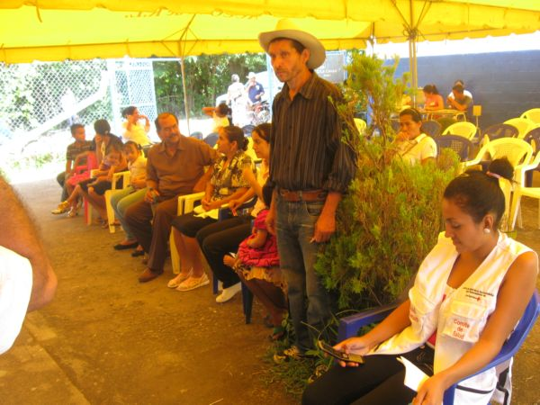 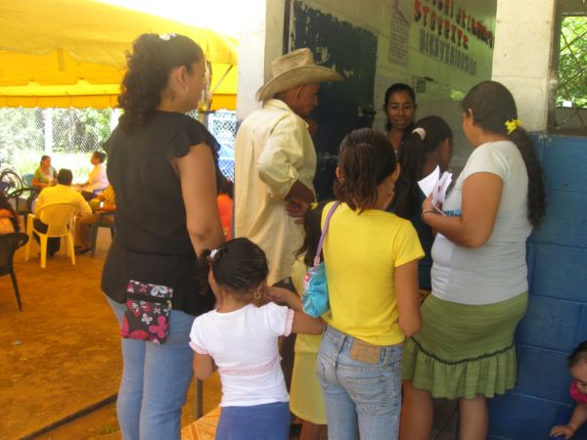
Calix residents in the waiting area Adults, children and elders get medical attention
El Calix residents held one-to-one conversations in six communities, and surveyed 160 people regarding their health needs. Most people expressed that although health care is good in the local Health Unit, the services aren’t enough - sometimes there is no medicine, and poverty prevents them from going to the clinic for medical attention. There is also a lack of specialized services for common diseases including high blood pressure, diabetes, and malnutrition. These problems resulted in leaders from the Christ the King Mission holding a health fair to meet the immediate health needs in the community, providing medical consultation and free medication to low-income people in the area.
Strong relationships were forged with health ministry officials of the Dept. of Usulutan, and a number of doctors and nurses volunteered their time to provide medical services. A range of pharmaceutical laboratories donated medication in response to a request by the congregation. Leaders are aware that immediate assistance is important, and they are also seeking improvements in the health system in the area and in the country. They have planned a series of workshops on health, and are holding
research meetings with departmental and national officials to learn more about the functioning of the health system in El Salvador.

The newest COFOA member is Nuestra Señora del Perpetuo Socorro. Leaders have participated in COFOA trainings using the PICO community organizing model. After a listening campaign, they identified the need for a bridge that connects the majority of the El Socorro community school children as their top priority, so that they increase access to their school center. During the rainy season, passage to the school is very difficult for the children, teachers, and cars: the most important concern is to assure that there is safe passage for all to get to the school, and to prevent any loss of life. COFOA leaders are now holding research meetings with public officials, to explain their concern and make sure that governing bodies are aware of the issue, and will respond to their needs.

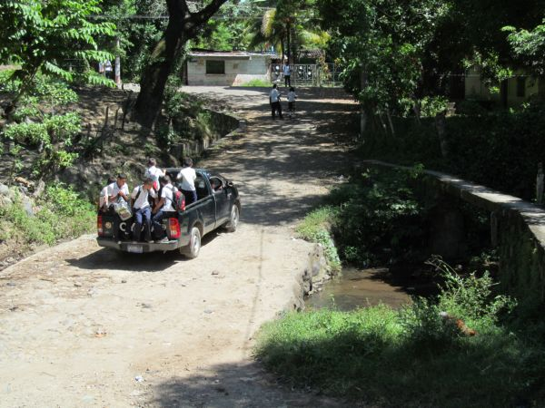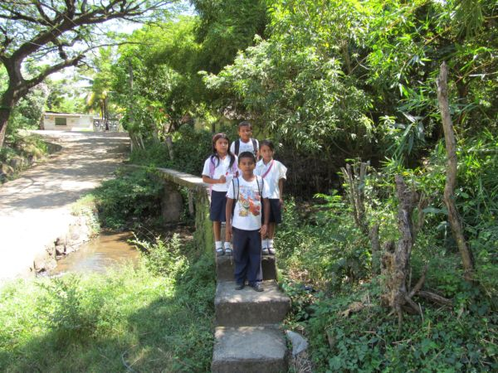
Pick up crossing the empty river before the rainy season Children crossing the bridge without any protection

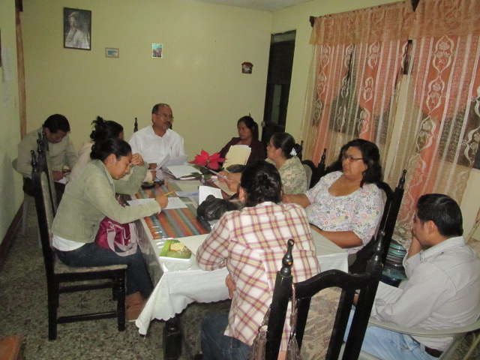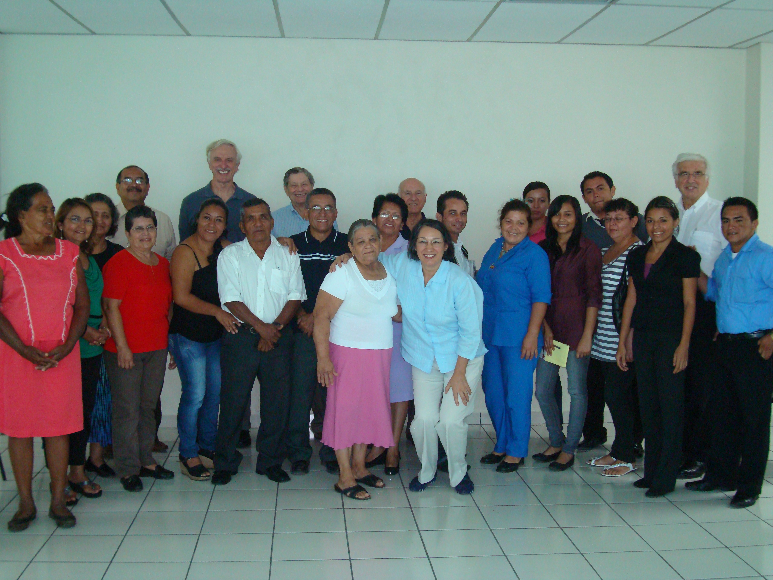
Guatemala leaders plan a safety campaign PICO Board members meet COFOA leaders

Guatemala progress. In January 2013, Guatemalan leaders from Pastores City held an important meeting with public officials and local institutions to establish a broad coalition of institutional and elected officials as part of an action committee to organize a march for peace in February 2013. Over 12 institutions signed a covenant to be part of the peace march and work with COFOA leaders in a permanent safety campaign.

Two PICO delegations visited COFOA leaders and communities in El Salvador and Guatemala in 2012. In August, eight PICO USA staff and leaders shared an intensive two-week immersion in PICO Central America’s work in Guatemala and El Salvador. They met with leaders, church representatives (including bishops in both countries) and public officials, and witnessed the work of Local Organizing Committees firsthand in Antigua, Guatemala and the Diocese of Zacatecoluca, El Salvador.

In October, a delegation representing the PICO National Board of Directors, including Father Michael Mandala, Father John Baumann, Hank Goldstein, Jose Debasa and his wife Pauline visited COFOA staff, clergy and leaders in El Salvador and Guatemala.

Each delegation received a warm welcome and had opportunities to visit numerous Local Organizing Committees, hear testimony from COFOA leaders and clergy, and learn about the depth of the problems that COFOA leaders are tackling, including safety/violence, health access, transportation, economic development, and resources for youth. COFOA leaders shared that they were amazed that they could have meetings with public officials and get the changes that are needed in their communities. PICO staff who participated in the August delegation commented on the deep level of ownership they observed by leaders in the local organizations of COFOA. They found their commitment inspiring, and were struck by the similarities with the work they are doing in the United States.

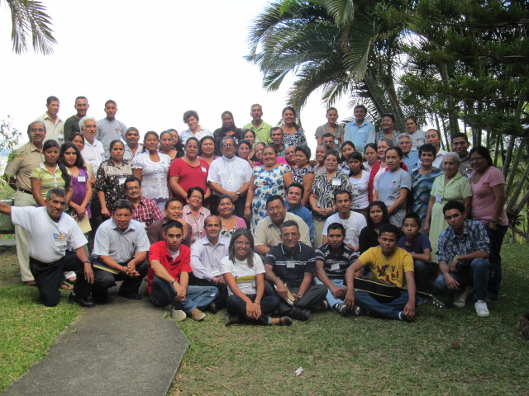
John Baumann SJ, COFOA staff and leaders at the regional training

The PICO Network and PICO International. Non-partisan and multicultural, PICO is one of the largest, most diverse grassroots community efforts in the United States, active in 19 states, involving over 50 religious denominations and faith traditions, and working in two international settings: Rwanda and Central America. Since 1972 PICO has provided an opportunity for people and congregations to translate their faith into action by supporting the development of low and moderate income leaders. Ongoing training builds these leaders’ capacity to identify issues and engage large numbers of community members in gaining commitments for equitable resources and policies, working on health care, housing, education, safety, immigration and local quality of life issues.

Please also visit our website and photo slideshow at www.picointernational.org . For more information, contact John Baumann, Founder and Director of Special Projects at 510-655-2801 or via email at jbaumann@piconetwork.org, or PICO-Central America Director Alberto Velazquez at avelazquez20@aol.com.

